Fundraising to Support L&B!

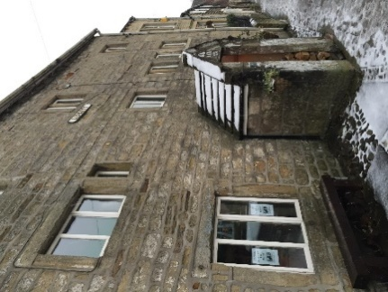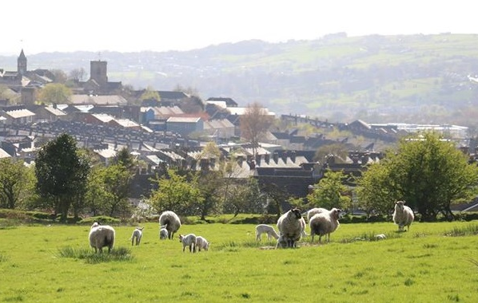

L&B raises funds from events, markets, selling merchandise, legacies and donations to support future activities, which will/may include:
- Fighting unsustainable/unsuitable housing applications, like the Upper Rough
- Ensuring any development is sensitive and appropriate
- Hiring professional advisors to assist with specialist input
- Playing our part in the Colne Neighbourhood Plan
- Enhancing the area for residents/visitors with displays, notices, leaflets etc
- Helping with developing and promoting the East Colne Way and Colne Boundary walks
- Sending out additional communications and leaflets to people

L&B claims 25% Gift Aid of your donation - please give as much as you can to help L&B and to help protect and enhance our area for you and future generations by:
- bank transfer (preferred) to Sort Code 05-03-83 A/c 34629856; or
- cheque payable to “Lidgett & Beyond”; or
- PayPal transaction (note that L&B pays 1.4% fees) with QR code
so you can donate via your PayPal account or a credit/debit card:

For us to recover Gift Aid, please complete the following information:

Full Name ………………………………………………………………………….
Address ……………………………………………………………………………….
………………………………………………. Post Code …………….……
Amount donated £……………………….
I am a UK tax payer and request that this and all subsequent donations to Lidgett & Beyond Charity be accepted under the Gift Aid scheme.
Thank you!
Signed …………………………………….. Date ………………………..
(or type italics)
If typing info in the box to return the Word doc to us, delete characters afterwards to keep the formatting!

Lidgett & Beyond Charity (Registered Number 1163523)
Protecting and Enhancing our Area & Colne’s Countryside and Green Lungs
www.lidgettandbeyond.org
Email info@lidgettandbeyond.org or call 07801 468303
Mail: c/o Heyroyd, Skipton Old Road, Colne BB8 7AD

